Abstract template for the ICCFM 2018 conference

Topic

Corresponding author,¹,∗ Contributing author,¹ and Contributing author²

¹Aﬃliation 1, address, city, country
²Aﬃliation 2, address, city, country

*Corresponding author: iccfm2018@bose.res.in

This is an abstract template for submission to the International Conference on Complex and Functional Materials (ICCFM 2018), to be held at the S. N. Bose National Centre for Basic Sciences, Kolkata, on the occasion of the 125th Birth Anniversary of Prof. S. N. Bose, during 13 - 16 December, 2018. Your abstract will serve a dual purpose of (1) selection of presentations by the Program Committee and (2) publication in the conference Book of Abstracts. Abstracts will be accepted in Microsoft word (doc or docs) file format only. Your abstract will not be edited upon acceptance, so please ensure it is submitted in its final publishable form.
Instructions for preparing the abstract are as follows:

- No more than 1 page, A4 or letter size. All margins should be at least 2.5 cm.
- Please use the Times font family.
- Single-spaced lines.
- Please use the following layout.

  - Title: 15 pt, boldface, centered

  - Authors: 11 pt, boldface, centered, presenting author underlined if known

  - Aﬃliations: 11 pt, italic, centered

  - Presenting author’s e-mail address

  - Main text: 11 pt, one column

  - References [1]

  - Table and figure captions should use font size 10.

- The total size of your contribution should not exceed 5MB.

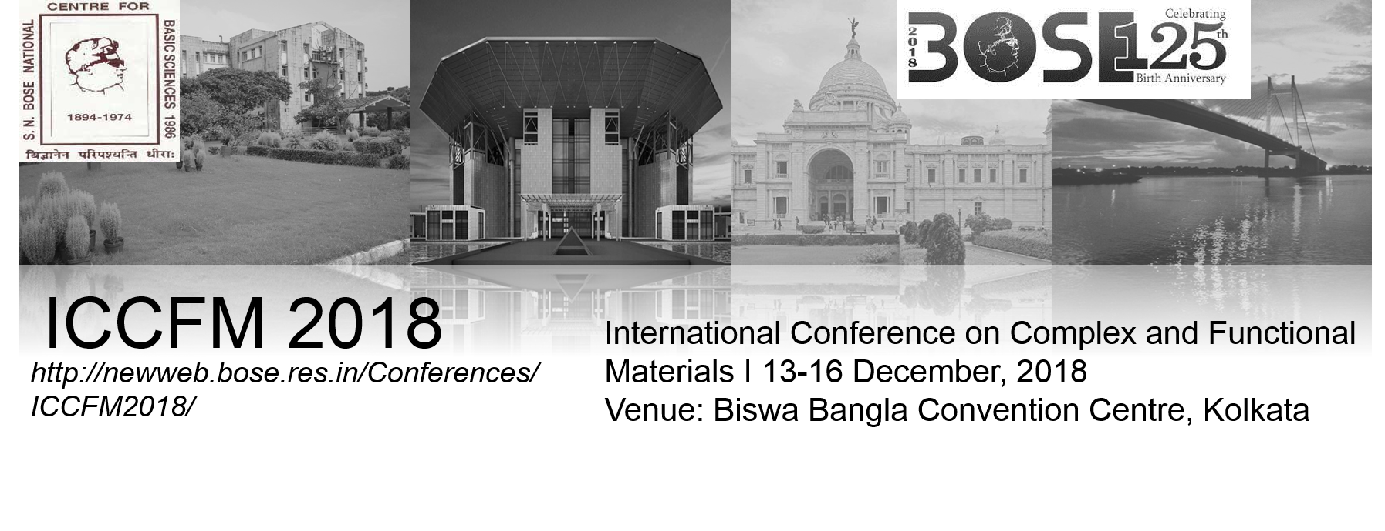

Figure 1: International Conference on Complex and Functional Materials (ICCFM 2018).

To submit your word Abstract please visit the conference abstract submission webpage: http://newweb.bose.res.in/Conferences/ICCFM2018/

References

[1] X. Yyyyyy, Phys. Rev B vol, pppppp (2016).

